Phenotypic Effects of Mutations
Mutations are classified is on the basis of their phenotypic effects. At the most general level, a mutation can be distinguished on the basis of its phenotype compared with the wild-type phenotype. A mutation that alters the wild-type phenotype is called a forward mutation, whereas a reverse mutation (a reversion) changes a mutant phenotype back into the wild type.
- Restoration of the original phenotype by reversion may occur by a true back-mutation at the same site in the gene as the original mutation, restoring the wild-type nucleotide sequence (change in same codon and same nucleotide). An exact reversal of the original mutation is called true reversion.

Forward mutation True reversion
AAA GAA AAA
(Wild type) (Mutant) (Wild type)
Codes for Lys Codes for Glu Codes for Lys

Change in nature of codon in mRNA due to mutation in DNA

- Restoration of the original phenotype by reversion may occur by an equivalent reversion which does not generate original condition at the gene level. However, it restores the wild-type phenotype due to formation of synonymous codon (change in same codon and different nucleotide).

Forward mutation Equivalent reversion
UCC UGC AGC
(Wild type) (Mutant) (Wild type)
Codes for Lys Codes for Glu Codes for Lys

Change in nature of codon in mRNA due to mutation in DNA

Suppressor mutations
A suppressor mutation is a genetic change that hides or suppresses the effect of another mutation. This type of mutation is distinct from a reverse mutation, in which the mutated site changes back into the original wild-type sequence. A suppressor mutation occurs at a site that is distinct from the site of the original mutation; thus, an individual with a suppressor mutation is a double mutant, possessing both the original mutation and the suppressor mutation but exhibiting the phenotype of an unmutated wild type. Like other mutations, suppressors arise randomly.

Intragenic suppressor mutation

An intragenic suppressor mutation is in the same gene as that containing the mutation being suppressed and may work in several ways. The suppressor may change a second nucleotide in the same codon altered by the original mutation, producing a codon that specifies the same amino acid as that specified by the original, unmutated codon. Intragenic suppressors may also work by suppressing a frameshift mutation. If the original mutation is a one-base deletion, then the addition of a single base elsewhere in the gene will restore the former reading frame. Consider the following nucleotide sequence in DNA and the amino acids that it encodes:

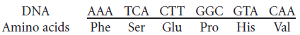

Suppose a one-base deletion occurs in the first nucleotide of the second codon. This deletion shifts the reading frame by one nucleotide and alters all the amino acids that follow the mutation.

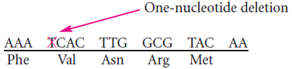

If a single nucleotide is added to the third codon (the suppressor mutation), the reading frame is restored, although two of the amino acids differ from those specified by the original sequence.

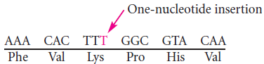

Similarly, a mutation due to an insertion may be suppressed by a subsequent deletion in the same gene.
A third way in which an intragenic suppressor may work is by making compensatory changes in the protein. A first missense mutation may alter the folding of a polypeptide chain by changing the way in which amino acids in the protein interact with one another. A second missense mutation at a different site (the suppressor) may recreate the original folding pattern by restoring interactions between the amino acids.

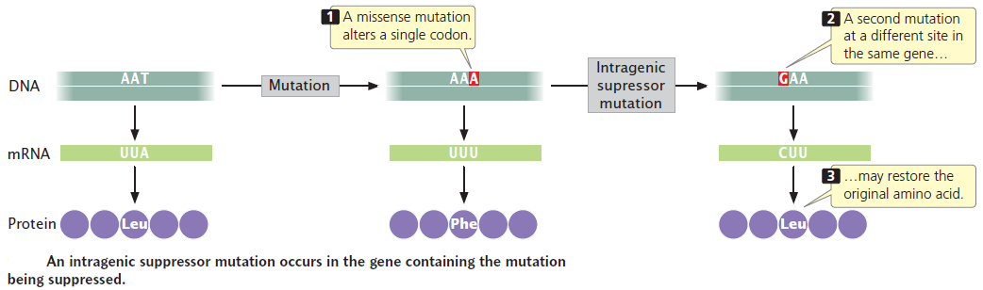

Intergenic suppressors mutations

An intergenic suppressor mutation, in contrast, occurs in a gene other than the one bearing the original mutation. These suppressors sometimes work by changing the way that the mRNA is translated. In the example illustrated in Figure a, the original DNA sequence is AAC (UUG in the mRNA) and specifies leucine. This sequence mutates to ATC (UAG in mRNA), a termination codon (Figure b). The ATC nonsense mutation could be suppressed by a second mutation in a different gene that encodes a tRNA; this second mutation would result in a codon capable of pairing with the UAG termination codon (Figure c).

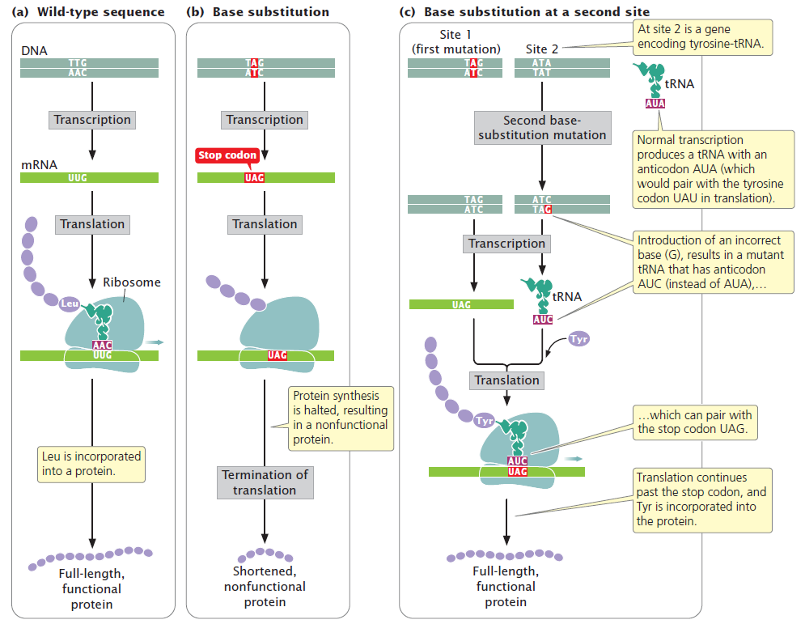

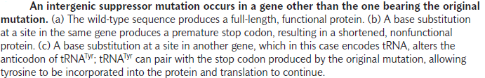

For example, the gene that encodes the tRNA for tyrosine (tRNA^{Tyr}), which has the anticodon AUA, might be mutated to have the anticodon AUC, which will then pair with the UAG stop codon. Instead of translation terminating at the UAG codon, tyrosine would be inserted into the protein and a full-length protein would be produced, although tyrosine would now substitute for leucine. The effect of this change would depend on the role of this amino acid in the overall structure of the protein, but the effect of the suppressor mutation is likely to be less detrimental than the effect of the nonsense mutation, which would halt translation prematurely.

